**PRACTICAL – 10**

**AIM:**

**Write an assembly language program to convert temperature in F to C.**

**C=(F-32) * 5/9**

**CODE:**

ORG 100H

MOV AL, 98

SUB AL, 32

MOV BL, 05

MOV CL, 09

DIV CL

MUL AL

DIV CL

RET

**OUTPUT:**

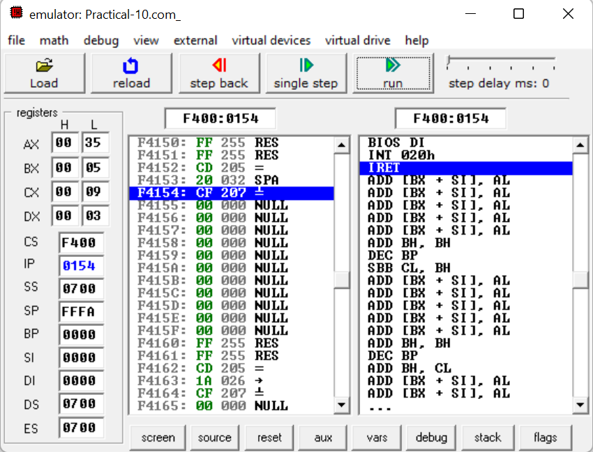

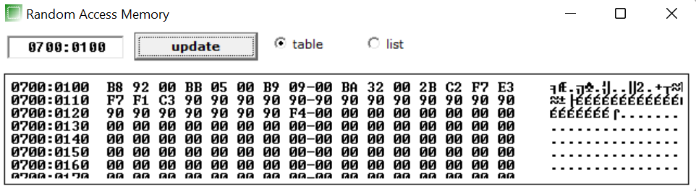

**CONCLUSION:** We learnt how to calculate Celsius from given fahrenheit by giving specific memory locations.